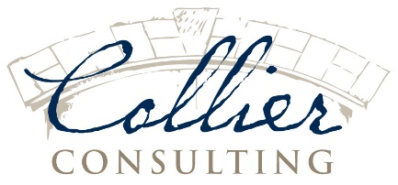

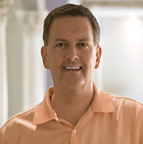

Thomas C. Collier, Jr.

Mobile
770-401-8033

Email
Collierconsultants1@.gmail.com

Collier Consulting
4405 Northside Pky. NW
Suite 2417
Atlanta, GA 30327
www.collierconsultants.com

Highly experienced construction and premises expert. Specializes in large commercial and multi-residential construction disputes and serious bodily injury claims. Has served on over 300 cases as an expert witness and dozens of cases as an arbitrator. 30+ years’ experience as a general contractor and owner/developer focusing on condominiums, roads, sewers, subdivisions, offices and other major construction. Summa Cum Laude/Phi Beta Kappa graduate of the University of North Carolina.
Professional experience:
Consultant (2008-Present): Georgia, North Carolina, Florida, Alabama, Mississippi, and Tennessee. Cases include commercial defects and delays, serious personal injuries, multifamily, sewers, roads and drainage, retail, insurance, professional liability, and construction business practices. Approximately equal representation of plaintiffs and defendants.

Arbitrator, American Arbitration Association (2008 – present): Georgia, Florida, and multi-state cases. Arbitrations include commercial, contracts, multi-party, residential, court-remanded, professional liability, pro se, and large panel cases involving delays, defects, liability, insurance, professional services, right-to-repair and other issues.

General Contractor - President of Buckhead Classic (2006 – presen): Projects include defective construction repair, new construction, fire and floods, structural defects, water damage, offices, demolition, sewer, water, drainage, and historic structures.

Owner/Developer and General Contractor – President, MilbCorp. (1984 – 2014): Projects include condominiums, roads and drainage, zoning, subdivisions, sewer, outfalls, water, drainage, for-sale homes, energy compliance, and professional offices, with cradle-to-grave responsibility for all projects.

Experience areas also include (but are not limited to):

- Contracts
- Business practices
- Partnerships
- Accounting
- Codes
- Property and Casualty insurance
- General Liability insurance
- Historical Construction
- Water and gas
- Fire and flood
- Retail structures and lability
- Falls (both on surfaces and through)
- Mobile homes
- Zoning
- Compliance
- Parking, streets and ADA
- Asbestos and lead remediation
- Pools and decks
- Stairs

- Accident causation
- Abandonment
- Fiduciary liability
- Real estate sales
- Architectural and engineering responsibility
- Surety claims
- Manufactured construction
- Subcontracting
- Supervision
- Best practices
- Condominiums
- Construction accidents

Education:
University of North Carolina at Chapel Hill - Economics and English, Summa Cum Laude
Johnston Scholar, Phi Beta Kappa - 1983.
Thesis on Disintermediation and Economic Cycles received Highest Honors
The Westminster Schools – 1979. Cum Laude, recipient of Special Award for Service, awarded only in select years.

Professional Associations:
American Arbitration Association Board of Neutrals, Current
Mediator, State of Georgia Office of Dispute Resolution, 2015-2018
Licensed Contractor State of Georgia, Current
Arbitrator - Construction Dispute Resolution Services, Current
Developers Association of Georgia (HBA) – Former Director, State Board of Directors, 1997-1998

Professional Certifications:
Mediation Certification and Practicum, Henning Mediation, 2016
Construction Dispute Resolution Services, Arbitration and Advanced Arbitration, 2016
AAA Certifications: Chairing an Arbitration Panel: Managing Procedures, Process & Dynamics, 2015; Managing Cases Involving Self-Represented (Pro-Se) Parties, 2015; Safeguarding, Deciding & Writing Awards, 2010; Arbitration Fundamentals and Best Practices for New Arbitrators, 2008

